OSLC Asset Management 2.0 Human Interaction Use Case

Overview
In this use case an administrator users delegated users interfaces embedded in a build system configuration tool to define a build specification which the automated tool will use to drive the nightly build. This is related to the extended build system use case where the build system uses the configured build process described here.

Preconditions
In order to automate the nightly builds of several software development teams there has been agreements made between the development and build teams on how to structure the asset in their repository. These arrangements will allow development teams to models the build environment and dependencies needed to build their product without having to involve a build engineer to make a change. The build team has created a web based interface which allows the development teams to create and update build processes.

System Design
The repository will operate under the following constraints to ensure build automation of the software projects:
- An asset of type Release will be created and managed by the development team for each software project under development. This top level asset would be the entry point for anyone looking for information about a project (links to documentation, downloads, bug tracking systems, forums etc).
- The development team will also maintain an asset of type Build Specification for each unique build configuration of that software Release. The Build Specification will be of and agreed upon format and will include everything the build systems need know about building an Implementation of this Release (build files, system requirements, dependency links, contact information, publish templates etc).

Asset Type Agreements
Development and the Build team agree upon the following constants on the Asset Types used by the automated build:

Release
- The Release Asset Type includes relationships of type Build Specification that points to an asset of type Build Specification for each unique build configuration that needs to be included in the nightly build.
- The Release asset also keeps a list of relationships of type Implementation which point to the an asset of type Implementation. The build process updates this after each new Implementation if published.

Build Specification
The Build Specification type is maintained by the development team to let the build systems know what needs to be built in the nightly build.

The agreed upon constraints for this type include...

- Relationships of type Dependency to all reusable components in the repository that will be need during build.
- Agreed upon classifications for all environment settings need to be setup prior to build (for example Java/JRE/IBM/1.5, Java/J2EE, Web/App Server/WAS 7, Database/DB2/9.5, ANT/1.6…).
- Agreed upon Build Frequency classification (for example DAILY, WEEKLY, MONTHLY).
- A Date property that indicates the last time this specification was built.
- A URL property that points to the base ANT file to be used during the build.
- A URL property that points to the Asset Resource XML template to be used by the build system to push the implementation.
- A mutli-valued Resource Reference property that points to the Work Items included in this build.

What Are Delegated User Interface
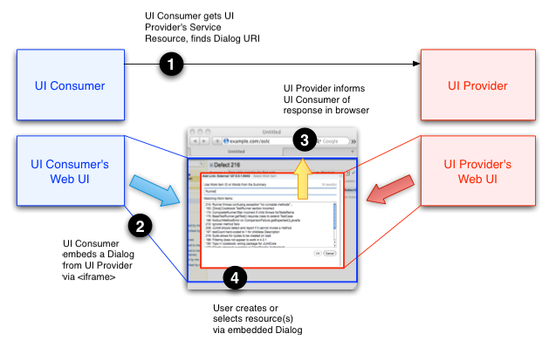
Delegated User Interface are described in the OSLC core specification. The OSLC Delegated User Interface (UI) Dialogs. Delegated UI Dialogs are a technique where one provider can embed a creation or selection UI into another using a combination of an HTML <iframe> and JavaScript code. The diagram below illustrates how delegated UI dialogs work in a scenario where Provider A wants to allow a user to select or create a resource managed by Provider B.
Asset management service providers should provide dialogs to allow other products more effectively achieve integrations.

User defines a new Build Specification:
- The developer goes to the build configuration tools site and asks to create a new Build Specification
- The developer clicks to open a search dialog to search for the Release asset for their project. As shown in the diagram the build system delegates to the Asset Management System to display a search dialog that will allow the developer to find the Release.
- The user enters the name of their project and presses search on the delegated UI.
- The Asset Management system returns a list of matching software projects.
- The developer selects the correct one and selects OK.
- In the build system UI there is now a link for the selected Release asset.
- When the user hovers over the link to the Release asset the Build System gets the delegated preview UI from the Asset Management System and displays it to the user.
- The user enters that this is a DAILY build.
- The users enters the following build categorizations (OS/Windows/XP, Java/JRE/IBM/1.5, Database/DB2/9.5) to explain to the automated build that it needs a windows environment, a 1.5 IBM JDK and and DB2 9.5 installed in the build environment.
- The user also uses the delegated search UI to choose the dependet common components needs for this build (log4j, jaxb, json lib etc).
- The developer provides the ANT file used to drive the build.
- The developer uploads the XML template that the build system will use to publish the Implementation Asset.
- The developer saves the configuration and lets the build system do it's job.

